First – The User

Id: 793

Name: Gisli

Weight: 90kg

Goals: Lose weight

Workout

Id: 123

Date: 08/12/2020

Type: Upper-body

List

Exercise

Bench press

Barbell Row

Pull Up

Exercise

Name: Bench Press

Type: Compound Exercise

Target: Chest

Order: 1,2,3 (Linear)

Sets:

List (sets)

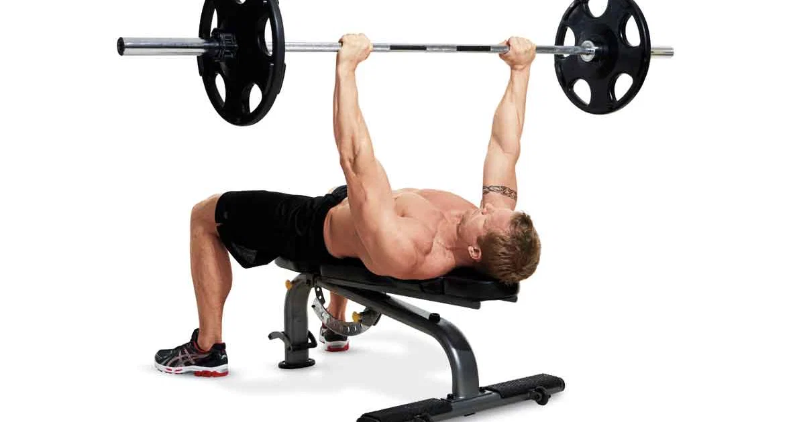

Sets

Reps: 8

Weight: 590lbs

Amount of sets: 3

Exercise

Name: Barbell Row

Type: Isolation

Target: Back

Order: Linear

Sets:

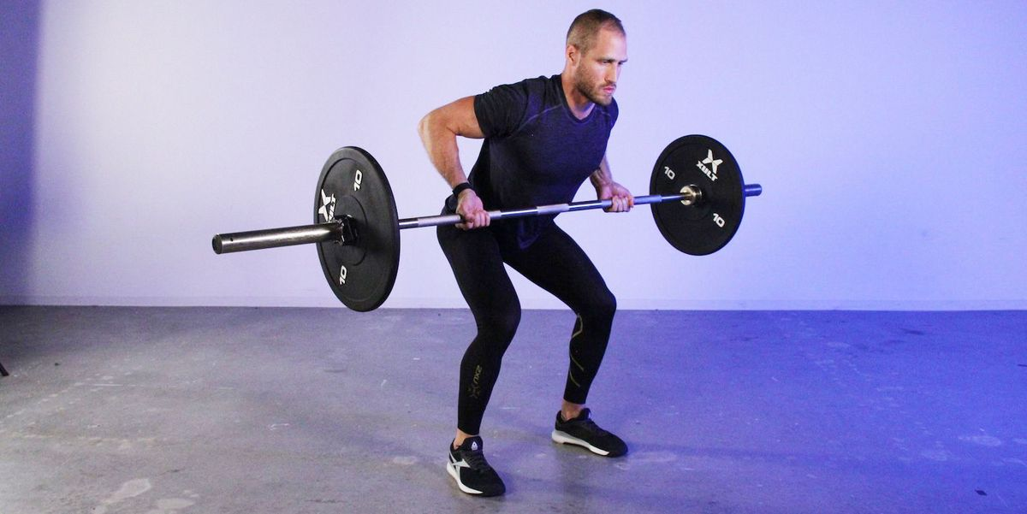

Sets

Reps: 15

Weight: 640lbs

Amount of sets: 4

Exercise

Name: Pull up

Type: Body Strength

Target: Back/Triceps

Order: Linear

Sets:

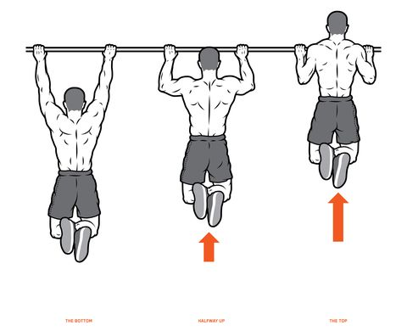

Sets

Reps:30

Weight: Body

Amount of sets:2

°-----------------------------------------------------------------------------------------------------------------------------°

Diet

Date: 08/12/2020

Calories: 3200

Protein : 120gr

Water intake: 3L

°-----------------------------------------------------------------------------------------------------------------------------°

Tracking function

Progress

Weekly calorie intake : 3156 a day avg

Weight movement : -3kg this week